# 04

hw01.Simple TV factory.  
A TV factory specializes in the production of all kinds of TV sets for each famous TV brand, when a Haier TV set is wanted, it is required to pass the parameter " Haier" when calling the factory method of the factory,when a Hisense TV set is wanted, we only need to pass the input parameters " Hisense ", the factory can return different brand of the TV set according to the different parameters.The Factory method pattern is used to simulate the production process of the TV factory.

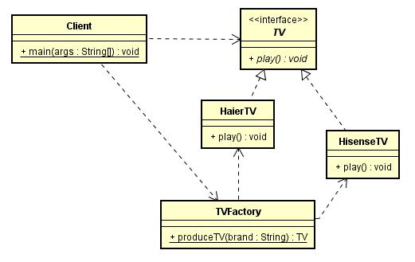

hw02. The following code is about how to decode an image based on the different formats.

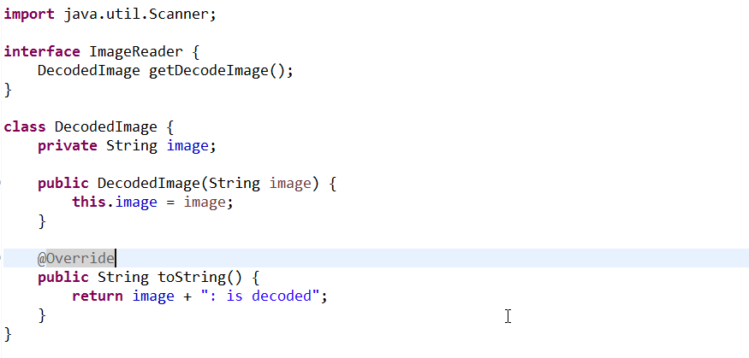

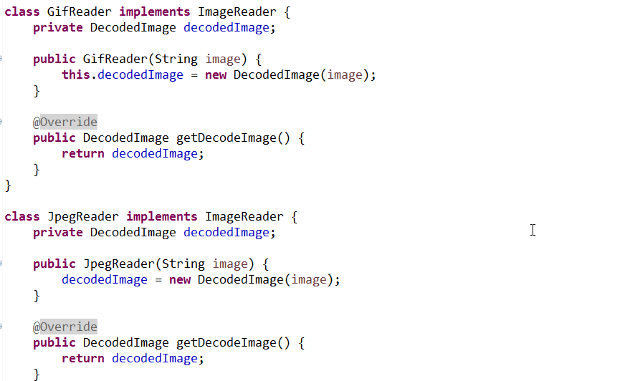

## hw03. In a simulation game, you are supposed to create different pets based on the sound they make, e.g, if the sound an animal make is "quack",then you should create a duck.